Experiment-20
Aim:
To write a Prolog program to create a database of planets and retrieve their details using queries.
Algorithm:
- Start the Prolog program.
- Define facts for the eight planets and their positions from the Sun.
- Create a rule to display all planets.
- Create a rule to search for a planet by name.
- Load the program into the Prolog interpreter.
- Execute the required query.
- Display the results.
- Stop the program.
Code:
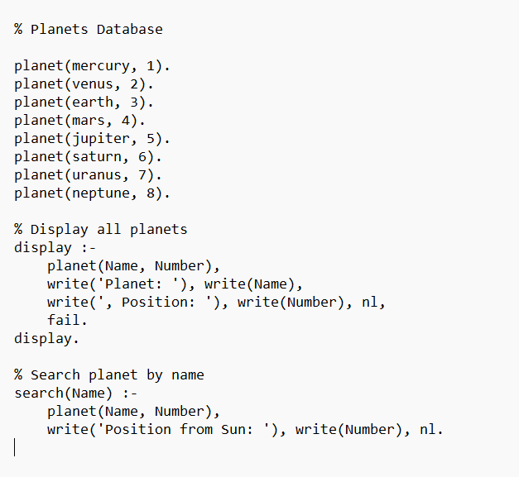
Output:
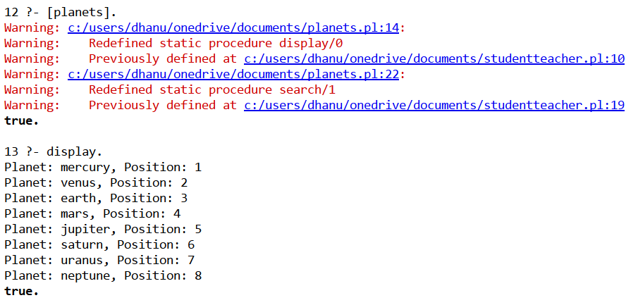
Result:
Thus the prolog program to create a database of planets and retrieve their details using queries.

